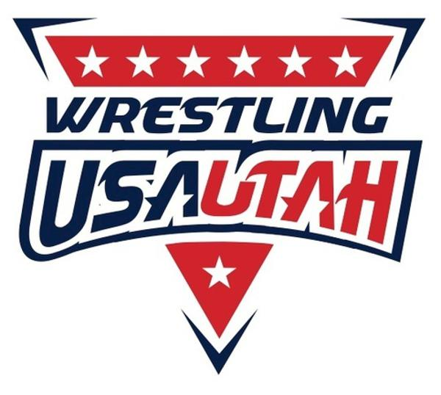 November Schedule

|  |  |  |  |  |  |  |
| --- | --- | --- | --- | --- | --- | --- |
| Sunday | Monday | Tuesday | Wednesday | Thursday | Friday | Saturday |
|  | 27 | 28 | 29  Info/Registration Night  6-7:30 | 30 | 31 | 1 |
| 2 | 3  Advanced Practice  5:30-7  Beginner Practice  7-8:30 | 4  Advanced Practice  5:30-7  Beginner Practice  7-8:30 | 5 | 6  Advanced Practice  5:30-7  Beginner Practice  7-8:30 | 7 | 8  Salt Lake Showdown @ Olympus HS |
| 9 | 10  Advanced Practice  5:30-7  Beginner Practice  7-8:30 | 11 | 12  Advanced Practice  5:30-7  Beginner Practice  7-8:30 | 13  Advanced Practice  5:30-7  Beginner Practice  7-8:30 | 14 | 15  Caleb Williams  Tournament @ Telos U Orem |
| 16 | 17  Advanced Practice  5:30-7  Beginner Practice  7-8:30 | 18  Advanced Practice  7-8:30 | 19  Advanced Practice  5:30-7  Beginner Practice  7-8:30 | 20  Beginner Practice  7-8:30 | 21 | 22  Charger Classic @ Corner Canyon HS |
| 23 | 24  Advanced Practice  7-8:30 | 25  Advanced Practice  5:30-7  Beginner Practice  7-8:30 | 26 | 27  Happy Thanksgiving! | 28 | 29  Turkey Tussle @ RSL Herriman |

* **You must have a USA wrestling card ($20) in order to compete in any tournaments**
  + **Add Riverton Wolfpack as your club affiliate**
* **Weigh-Ins for every tournament will occur Thursdays after practice**
* **Please register for all tournaments on Track Wrestling**
* **Info on how to register for a USA wrestling card and for Trackwrestling can be found on our team website**